Gen Ai project EDA and preprocessing

Dataset: resume_data.csv
Shape: (9544, 35) (9,544 rows × 35 columns)
Columns and what they mean for this project
 | Column | Role | Filled | Fill % | Sample
0 | address | RESUME | 784 | 8% | Sunnyvale, CA
1 | career_objective | RESUME | 4740 | 50% | Big data analytics working and database warehouse manager wi
2 | skills | RESUME ⭐ | 9488 | 99% | ['Big Data', 'Hadoop', 'Hive', 'Python', 'Mapreduce', 'Spark’]
3 | educational_institution_name | RESUME | 9460 | 99% | ['The Amity School of Engineering & Technology (ASET), Noida
4 | degree_names | RESUME | 9460 | 99% | ['B.Tech']
5 | passing_years | RESUME | 9460 | 99% | ['2019']
6 | educational_results | RESUME | 9460 | 99% | ['N/A']
7 | result_types | RESUME | 9460 | 99% | [None]
8 | major_field_of_studies | RESUME | 9460 | 99% | ['Electronics']
9 | professional_company_names | RESUME | 9460 | 99% | ['Coca-COla']
10 | company_urls | RESUME | 9460 | 99% | [None]
11 | start_dates | RESUME | 9460 | 99% | ['Nov 2019']
12 | end_dates | RESUME | 9460 | 99% | ['Till Date']
13 | related_skils_in_job | RESUME | 9460 | 99% | [['Big Data']]
14 | positions | RESUME | 9460 | 99% | ['Big Data Analyst']
15 | locations | RESUME | 9460 | 99% | ['N/A']
16 | responsibilities | RESUME | 9544 | 100% | Technical Support\nTroubleshooting\nCollaboration\nDocumentatio
17 | extra_curricular_activity_types | RESUME (sparse) | 3426 | 36% | ['Professional Organization', 'Honor Society', 'Honor Societ
18 | extra_curricular_organization_names | RESUME (sparse) | 3426 | 36% | ['Ohio Society of CPAs', 'Beta Alpha Psi', 'Golden Key Inter
19 | extra_curricular_organization_links | RESUME (sparse) | 3426 | 36% | [None, None, None, None]
20 | role_positions | RESUME (sparse) | 3426 | 36% | [None, None, None, None]
21 | languages | RESUME (sparse) | 700 | 7% | ['Spanish']
22 | proficiency_levels | RESUME (sparse) | 700 | 7% | ['N/A']
23 | certification_providers | RESUME (sparse) | 2008 | 21% | ['Ohio Notary Public']
24 | certification_skills | RESUME (sparse) | 2008 | 21% | [None]
25 | online_links | RESUME (sparse) | 2008 | 21% | [None]
26 | issue_dates | RESUME (sparse) | 2008 | 21% | [None]
27 | expiry_dates | RESUME (sparse) | 2008 | 21% | ['February 15, 2021']
28 | job_position_name | JD ⭐ | 9544 | 100% | Senior Software Engineer
29 | educationaL_requirements | JD | 9544 | 100% | B.Sc in Computer Science & Engineering from a reputed univer
30 | experiencere_requirement | JD | 8180 | 86% | At least 1 year
31 | age_requirement | JD | 5457 | 57% | Age 22 to 30 years
32 | responsibilities.1 | JD | 9544 | 100% | Technical Support\nTroubleshooting\nCollaboration\nDocumentatio
33 | skills_required | JD ⭐ | 7843 | 82% | Brand Promotion\nCampaign Management\nField Supervision\nMercha
34 | matched_score | LABEL ⭐ | 9544 | 100% | 0.85

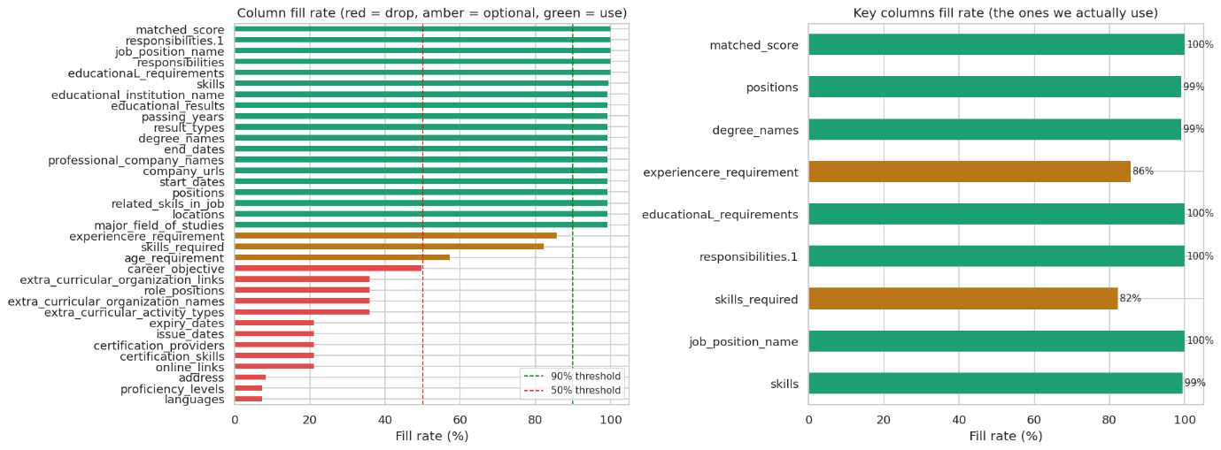
Saved: outputs/plots/01_null_analysis.png
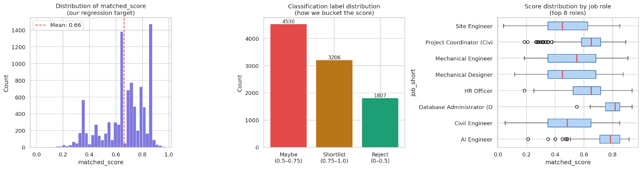
📊 matched_score statistics:
count 9544.000
mean 0.661
std 0.167
min 0.000
25% 0.583
50% 0.683
75% 0.793
max 0.970

Unique score values: 345
Saved: outputs/plots/02_score_distribution.png

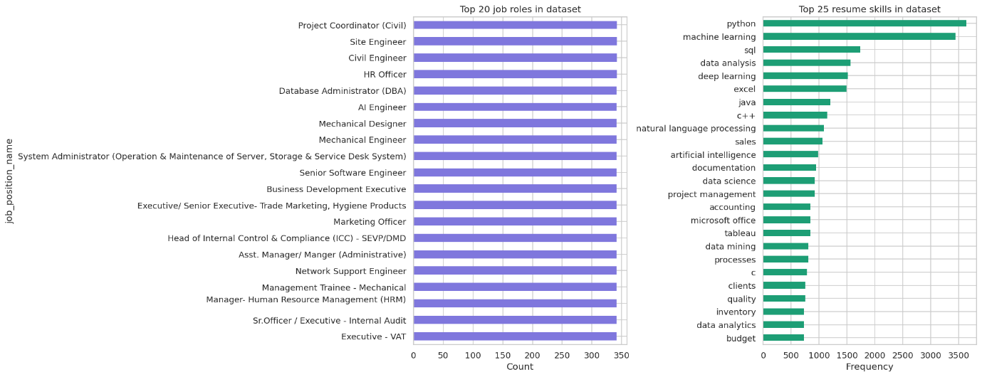
Total unique resume skills found: 2,797
Saved: outputs/plots/03_job_skill_distribution.png

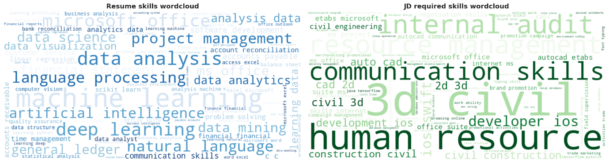
Total unique JD skills found: 97
Saved: outputs/plots/04_wordclouds.png
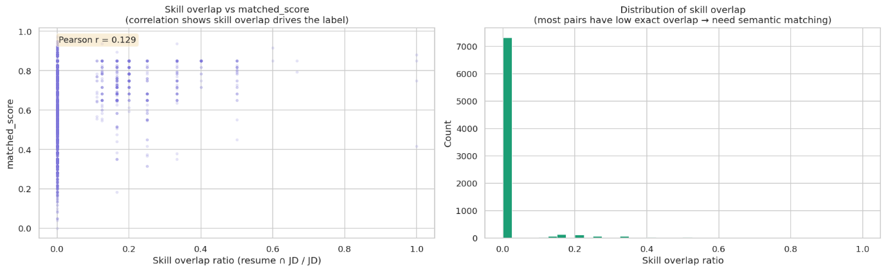
Mean skill overlap: 0.015
Correlation (overlap vs score): 0.129

⚠ Low mean overlap proves WHY semantic matching (SBERT) is needed — exact overlap alone is insufficient.
Saved: outputs/plots/05_skill_overlap_eda.png
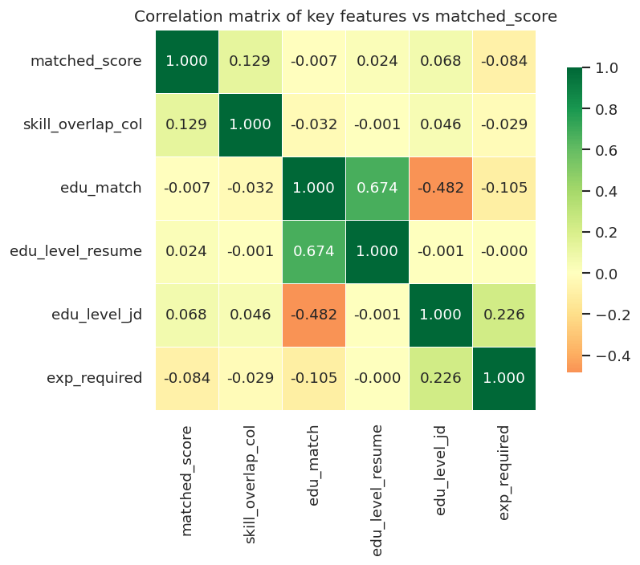
Saved: outputs/plots/06_correlation_matrix.png

PREPROCESSING
Starting rows: 9,544
After dropping rows with null skills or skills_required: 7,797
After dropping rows with empty parsed skill lists: 7,751

✅ Step 1–5 complete. Clean rows: 7,751
resume_skills — avg skills per resume: 21.9
jd_skills — avg skills per JD: 4.4
✅ Feature engineering complete.
Feature columns: ['feat_skill_overlap', 'feat_resume_skill_count', 'feat_jd_skill_count', 'feat_missing_skill_count', 'feat_edu_match', 'feat_edu_level_resume', 'feat_edu_level_jd', 'feat_exp_years_required', 'feat_resume_text_len']

SBERT
Classification label distribution:
label
Maybe 3438
Shortlist 2699
Reject 1614
SBERT similarity computed. Mean: 0.258
Correlation with matched_score: 0.162

Feature distribution plots
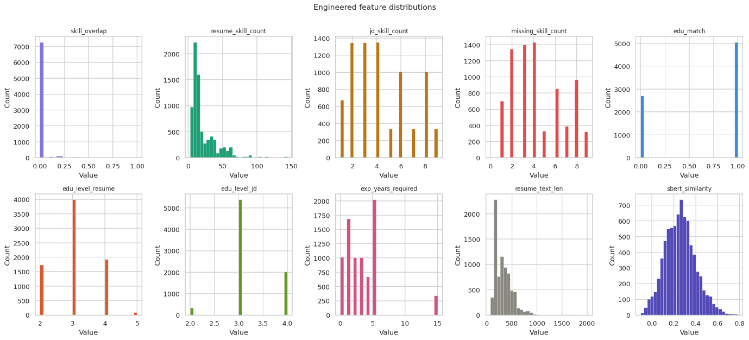
Saved: outputs/plots/07_feature_distributions.png
FAISS
Total unique skills in RAG corpus: 2,831
Sample skills: ['.net', '.ney(vb, asp)', '10key by touch', '15+ years of experience in accounting & bookkeeping services', '2-tier', '2000', '3d modeling', '3d printing', '3ds max', '3dsmax']
Saved: outputs/skill_corpus.json

FAISS index built. Vectors stored: 2,831 | Dimension: 384
Saved: outputs/skill_faiss.index

🔍 RAG test — query: 'machine learning'
→ machine learning (similarity: 1.000)
→ applied machine learning (similarity: 0.780)
→ machine learning engineering (similarity: 0.756)
→ learning algorithm (similarity: 0.732)
→ data mining (similarity: 0.720)

Final clean dataset shape: (7751, 23)

Column dtypes:
jd_title object
career_objective_clean object
responsibilities_clean object
resume_skills object
degree_names object
positions object
jd_responsibilities object
jd_skills object
jd_education_req object
jd_experience_req object
missing_skills object
feat_skill_overlap float64
feat_resume_skill_count int64
feat_jd_skill_count int64
feat_missing_skill_count int64
feat_edu_match int64
feat_edu_level_resume int64
feat_edu_level_jd int64
feat_exp_years_required int64
feat_resume_text_len int64
feat_sbert_similarity float32
matched_score float64
label object

Null counts in final dataset:
degree_names 69
positions 69

Final clean dataset
Train: 5,428 rows (70%)
Validation: 1,160 rows (15%)
Test: 1,163 rows (15%)

Label distribution across splits:
Train : Maybe: 44% | Shortlist: 35% | Reject: 21%
Val : Maybe: 44% | Shortlist: 35% | Reject: 21%
Test : Maybe: 44% | Shortlist: 35% | Reject: 21%

✅ Splits saved:
outputs/train.csv
outputs/val.csv
outputs/test.csv
outputs/full_clean.csv

✅ Config saved: outputs/preprocessing_config.json

{
"feature_cols": [
"feat_skill_overlap",
"feat_resume_skill_count",
"feat_jd_skill_count",
"feat_missing_skill_count",
"feat_edu_match",
"feat_edu_level_resume",
"feat_edu_level_jd",
"feat_exp_years_required",
"feat_resume_text_len",
"feat_sbert_similarity"
],
"regression_target": "matched_score",
"classification_target": "label",
"class_labels": [
"Reject",
"Maybe",
"Shortlist"
],
"edu_rank_map": {
"phd": 5,
"ph.d": 5,
"doctorate": 5,
"m.tech": 4,
"mtech": 4,
"m.sc": 4,
"msc": 4,
"mba": 4,
"master": 4,
"m.e": 4,
"b.tech": 3,
"btech": 3,
"b.sc": 3,
"bsc": 3,
"b.e": 3,
"bachelor": 3,
"be": 3,
"diploma": 2,
"hsc": 1,
"ssc": 1
},
"split_random_state": 42,
"train_size": 5428,
"val_size": 1160,
"test_size": 1163,
"total_clean_rows": 7751,
"unique_jobs": 23,
"unique_skills_in_rag": 2831,
"sbert_model": "all-MiniLM-L6-v2",
"faiss_index_path": "outputs/skill_faiss.index",
"skill_corpus_path": "outputs/skill_corpus.json"
}
============================================================
PREPROCESSING COMPLETE — OUTPUT FILES
============================================================
✅ outputs/full_clean.csv 10207 KB — Full preprocessed dataset (all rows)
✅ outputs/train.csv 7141 KB — Training split (70%) — feed to model notebook
✅ outputs/val.csv 1519 KB — Validation split (15%) — hyperparameter tuning
✅ outputs/test.csv 1548 KB — Test split (15%) — final evaluation only
✅ outputs/skill_corpus.json 66 KB — RAG knowledge base — list of all unique skills
✅ outputs/skill_faiss.index 4247 KB — FAISS index — load this for Agent 2 at inference
✅ outputs/preprocessing_config.json 1 KB — Feature names + config — load in every other notebook
✅ outputs/plots/ 1475 KB — All EDA plots (include in research paper)

